**Scott, Michael (1905-1989)**

Michael Scott was the foremost proponent of Modern architecture in Ireland during the mid 20th century. He specialised in public commissions, particularly hospitals and transport hubs, as well as private houses. His rural hospital designs in the late 1920s and 1930s were influenced by Finnish and Dutch work by ALVAR AALTO and J.J.P. OUD, emphasising linear horizontal masses, often finished with decorative limestone cladding. He was responsible for promoting the International Style to both Irish architects and the Irish government from the 1930s, and designed the award-winning Irish Pavilion at the 1939 New York WORLD’S FAIR (see Fig. 1). His later work was characterised by the sculptural use of white concrete forms, as in his own home Geragh (see Fig 2), and the integration of artwork, bringing colour and texture into his buildings. He is best known for the CORBUSIAN design of the Dublin central bus depot Busáras, which used asymmetric organic shapes and incorporated coloured mosaic into the exterior (see Fig. 3). He influenced several generations of Irish architects through his practice (now Scott Tallon Walker), and was awarded the RIBA Gold Medal for Promotion of Architecture on his retirement in 1975.

**List of Works**

1936 Nenagh General Hospital, Co. Tipperary, Ireland

1937 Tullamore Hospital, Co. Offaly, Ireland

1939 Geragh, Sandycove, Co. Dublin, Ireland

1939 Irish Pavilion, New York World’s Fair, New York, USA

1940 Portlaoise General Hospital, Co. Laoise, Ireland

1950 Inchicore Chassis Works, Dublin, Ireland

1952 Donnybrook Bus Garage, Dublin, Ireland

1953 Busáras, Store Street, Dublin, Ireland

1966 Abbey Theatre, Abbey Street, Dublin, Ireland

**References and further reading**

Larmour, P. (2009) *Free State Architecture:  Modern Movement architecture in Ireland, 1922-1949*, Kinsale: Gandon Editions.

O'Regan, J. & Dearey, N. (eds.) (1995) *Michael Scott Architect in (casual) conversation with Dorothy Walker*, Kinsale: Gandon Editions.

O’Regan, J. (1993) *Works 10: Michael Scott 1905-1989*, Dublin: Gandon Editions.

Rothery, S. (1991) *Ireland and the New Architecture 1900-1940*, Dublin: Lilliput Press.

Rowley, E. ‘The Conditions of Twentieth Century Irish Architecture 1900-1970’ in Kennedy C. (ed.) (2011) *The Moderns: The Arts in Ireland from the 1900s to the 1970*, Dublin: Irish Museum of Modern Art, pp. 418-475.

Irish Architectural Archive. Scott Tallon Walker Collection, Acc. 80/21, Michael Scott collection, Accs. 79/10(drawings), 89/44(drawings) and 2000/98(personal).

Web references

‘Busaras: RIAI Gold Medal Winner 1953-1955’, *Irish Architecture Gallery*, Available: <http://www.irisharchitectureawards.ie/index.php/gold-medal/winner/busaras/>

‘Scott, Michael (1905-1989)’ *Archiseek*, Available: <http://archiseek.com/2009/michael-scott-1905-1989/>

‘Scott, Michael John’, *Dictionary of Irish Architects*, Available: <http://www.dia.ie/architects/view/4782>

‘Scott Tallon Walker Architects: Projects: Heritage’ *Scott Tallon Walker*. Available: <http://www.stwarchitects.com/projects-heritage.php>

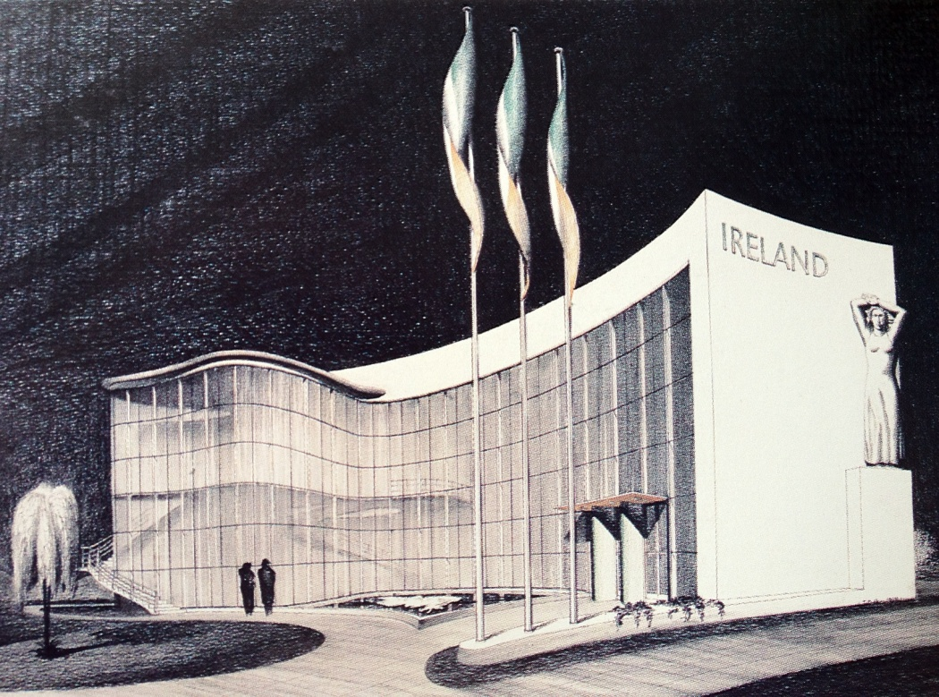

Fig. 1 – Michael Scott Architects, Irish Pavilion, exterior drawing, New York World’s Fair, 1939 (source IAA)

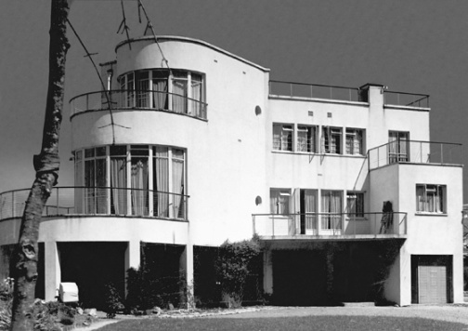

Fig. 2 – Michael Scott Architects, Geragh, Sandycove, Co. Dublin, exterior photograph, 1938 (source IAA)

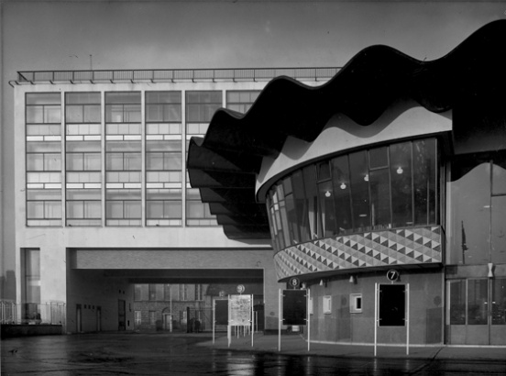

Fig. 3 – Michael Scott Architects, Busáras, exterior photograph, 1953

Video

‘Michael Scott: A Changing Man by Scott Tallon Walker Architects’, *Vimeo*, <http://vimeo.com/8621430>